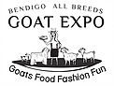
BENDIGO ALL BREEDS GOAT EXPO
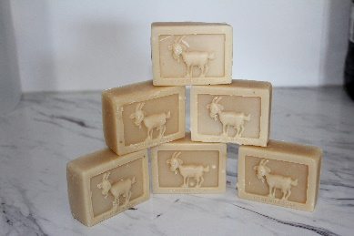
GOAT MILK SOAP COMPETITON
$2 PER ENTRY Please read rules and definitions before entering. Soaps will not be returned.
All soap to be Cold Process and the work of the entrant. Include 2 soaps per entry one for display and one for testing. (Please label display soap).
Ingredient list to be with entry not recipe.
Soaps will be judged on appearance, lather, feel.
CLASS 1 Plain unscented
CLASS 2 Scented and coloured may include essential and fragrance oils, clays, micas and other colourants
CLASS 3 Botanicals must be of plant origin ( may include oats, honey, flowers)
CLASS 4 Design soap coloured or patterned. May be any design and may be scented or unscented must be at least two colours
CLASS | SOAP DESCRIPTION | FEE
DETAILS
Name……………………………………………………………………………………………………………………………………………..
Address…………………………………………………………………………………………………………………………………………..
…………………………………………………………………………………………………………………………………………………………
PHONE……………………………………………Email……………………………………………………….……………………………..
Entries close 31st March. Soaps must be received by that date.
Soap and Forms to be sent to3551
SARAH POYSER 92 MCKINNONS ROAD LOCKWOOD , VIC
Direct Deposit NAB CAPROTEK 083-561 530126807 PLEASE PUT SURNAME AS REFERENCE
If you are unable to direct deposit please contact Belinda Cardinal 0418 573 458 for alternative payments

