AUSTRALIAN BROWN
History
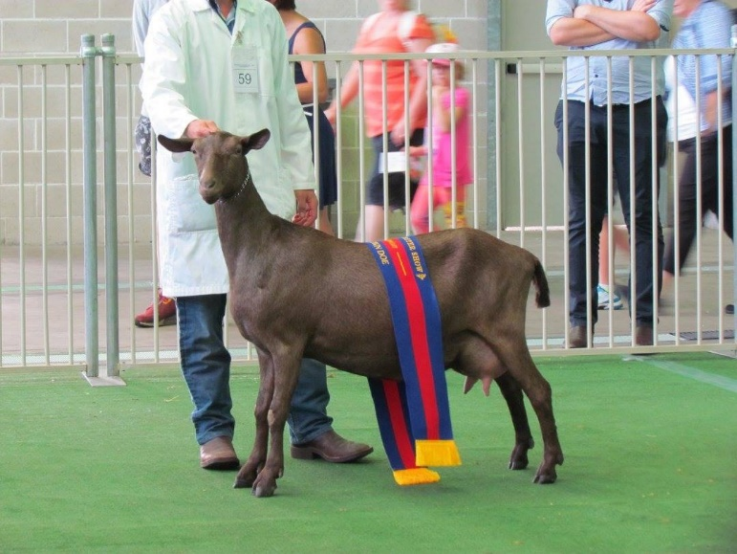
Developed in Australia in the 1990’s and recognized as a breed in 2006.

Characteristics
Long lactations
Docile natured making them easy to milk
Good butterfat content
Large milk producer
Robust

