History
The Anglo Nubian was developed in Great Britain using Middle Eastern and Indian stock, firstly with existing native goats and later by crossing with the imported Swiss breeds. The Middle Eastern breeds were Nubians from Egypt and Zariby from Eritrea, while the Indian breeds were the Jumna Pari and Chitral. Thses exotic breeds were of differing build and appearance, but all distinctly different to the British goats with the crossbred offspring showing distinct ‘Nubian’ characteristics.
The Anglo Nubian was well established in Britain prior to the introduction of the Swiss breeds, with goats appearing at the first goat show in 1875. They had either mottled or solid coats and a distinctive arched head with long pendulous ears.
Importations until 1904 ensured that the breed’s ‘Nubian’ character was maintained and in 1910 to breed was entered into the British Herd Book.
Only ten of the breed were imported into Australia in 1954 and all Anglo Nubians are descended from these imports. Crossbreeding helped to establish the breed.
The Anglo Nubian is regarded as having a higher butterfat percentage and better fleshing qualities than the Swiss breeds. Having been bred from hot climate goats, the breed is well suited to Australian conditions.
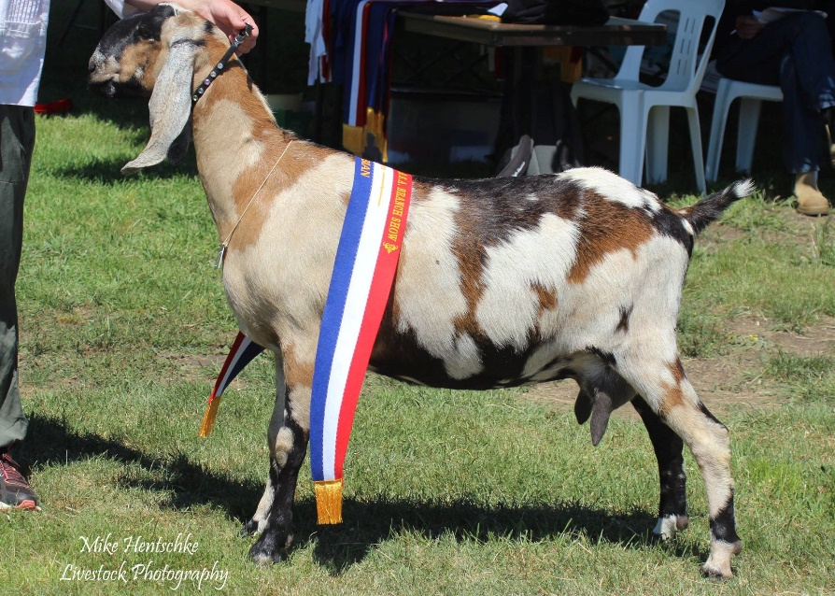

Breed standard
GENERAL APPEARANCE (style & quality):The ideal is a large exotic animal with a high, proud head-carriage, majestic bearing and upright stance. The goat should show the true attributes of sound dairy type.
HEAD (skull, eyes, ears, mouth, nostrils):Profile short and arched. Polled or neatly disbudded. Muzzle fine and tapered, nostrils flat, ideally the bite should be where the teeth fit snugly against the dental pad, but the teeth may extend beyond the dental pad. Ears low set on the head, long, broad and pendulous. Eyes should be almond shaped and set wide apart.
NECK:Strong, medium length and without tassels. Dewlap may to present on both bucks and does.
BACKLINE:Straight back either level or rising slightly to hips. May show slight dip behind withers but with no signs of weakness.
FOREQUARTERS:Withers well defined, blending firmly into shoulders. Chest broad and deep.
BODY (barrel):Heavy framed with good length and reasonable depth.
HINDQUARTERS:Rump rounded, broad and strong but not steep. Wide between thurls, tail short.
LEGS (hooves):Hooves sound and well formed. Legs strong and straight with no inclination to cow hocks or weak pasterns, which should be short, strong and upright.
UDDER:Showing a broad attachment and no pocket, softly textured with good capacity. Slight division allowed.
TEATS:Of good size, set well apart and distinct from the udder.
TESTICLES:Well developed, evenly balance, not divided, carrying two testes.
RUDIMENTARY TEATS:Two, set wide apart slightly to the fore and side of the scrotum, of good size but not overdeveloped, unless the buck is milking.
SIZE (height):Does 81 cm (32 inches). Bucks 94cm (37 inches).
COAT:Short, fine and glossy.
COLOUR:Any colour or combination of colours. May be plain, broken coloured, or mottled, but should not carry full Swiss markings. Skin black, but may be grey with black pigmentation.
DIFFERING FROM THE IDEAL (found and recognised):Horned, Wry tail. Slightly overshot jaw (the teeth may extend beyond the dental pad in older goats giving the appearance of a slightly overshot jaw, but it is the top of the teeth that are out of line, not the actual jaw).
FAULTS:Fine bone and lack or size. Short, stiff ears. Straight profile. Tassels. Cow hocks, dropped pasterns. Size differing substantially from ideal. Substantially overshot jaw. Visible teeth. Roach back or sway back. Tan skin. Poor feet. Splayed feet. Weak or narrow chest. Lack of dairy quality. Fleshy udder. Pocket in udder. Teats: small; thin; ill-defined or unbalanced. Lack of milking capacity. Lack of masculinity in bucks. Unduly pendulous, divided or uneven scrotum.
DISQUALIFICATIONS:Undershot jaw. Double teats. Double orifices. Supernumerary teats. Intersex. Pink skin. Wry face. Undescended testicles or one testicle. Boer goat colouring (white with coloured head).

