D.G.S.A. VICTORIAN BRANCH INC.

Annual Show - 2018

IN CONJUNCTION WITH BALLARAT AGRICULTURAL & PASTORAL SOCIETY INC. - 152nd ANNUAL SHOW
Date: 11th November 2018
Venue: Ballarat Showgrounds.

Entries to be forwarded to: Ballarat Show Secretary,
P. O. Box 401, Ballarat. 3353

*** Entries Close – 26/10/18 ****
NO LATE ENTRIES can be accepted due to unreliable Australia Postal service for return of tickets

Entry Fees: $3.50 per class (or $2.50 for members)
Chief Steward: Glenis Keays - ‘ph 0481 481 609

Ballarat Show Society prefer entries to come through “Nominate” - details on their web-site
or
Please make cheques payable to: Ballarat Agricultural & Pastoral Society Inc. OR
Direct debit BSB 633 000 Ac 162655906 – please quote your name & section

REGULATIONS

1. Entry fees must accompany entries
2. All goats must be registered (or registration applied for) with the DGSA.
3. Classes may be amalgamated or divided at the discretion of the judge/stewards. All handlers to wear white coats/clothing in the show ring.
4. Type & Production Classes - Points on Milk Production Show Cards MUST be included on entry. Type & Production points Cards MUST be brought to the show and WILL be inspected by the stewards. All valid cards have no time limit. Entries in T & P Classes will be disqualified if Exhibitors fail to present relevant Show Cards for inspection when required.
5. Classes marked * are special classes. Goats in these classes must also be entered in their appropriate age/breed classes.
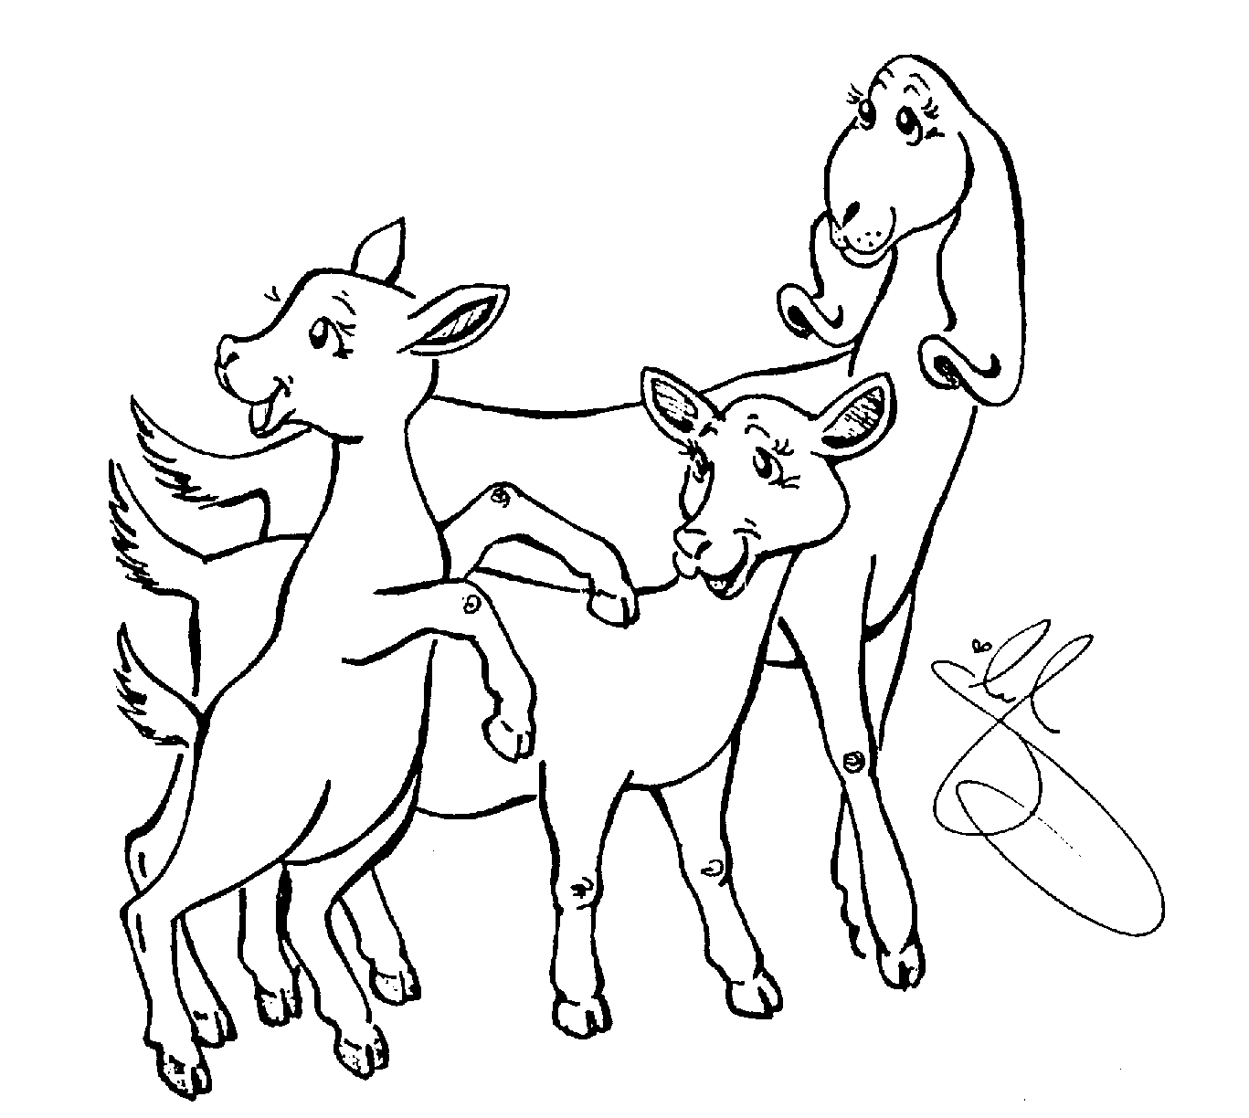
7. Exhibits are to be ready when classes are called or may be disqualified. This is necessary because of the size of the show.
8. All ages are to be given as at the date of the Show. Senior Does must be in milk.
9. All queries or complaints to be directed to the Head Steward whose decision shall be final.
10. Exhibitors are to report to the Head Steward on arrival to arrange tattoo checks, advise of scratchings & receive catalogues. Winners' tattoos may be inspected
11. Exhibits are to be penned by 9.00 am.
12. ALL does are to be presented for assessment prior to the best vessel classes then milked out for final assessment by the judge whether or not they are entered in best vessel classes. Only does entered in best vessel classes will then remain in the ring for awarding of places.
13. It is the exhibitors' responsibility to ensure does are milked out in a reasonable time.
14. CAE & JD negative show. Exhibits over 12 months of age must have tested CAE & JD negative. Exhibitors must forward proof with entries or entries will not be accepted. The certificate must contain results of the blood test and each goat is to be identified appropriately on the result sheet.
15. When completing entries PLEASE MAKE SURE ALL COLUMNS ARE COMPLETED. Any entry not fully completed or if CAE & JD certificates are not enclosed they will be returned to the exhibitor.

