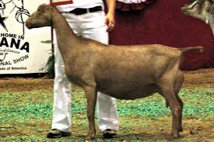
LA MANCHA
History
La Ma are also known for their high milk production, and the comparatively high butterfat content in their milk. The La Mancha goat is the only breed of goat developed in the United States. Although it is interesting folk lore and short eared goats do run throughout history, there is not, nor has there ever been, a breed known as the Spanish La Mancha. The Term "American La Mancha" is an ADGA term which denotes a goat that is mostly Lamancha but has unknown genetics or varied genetics of other purebred goats
Characteristics
Good Butterfat
High Producers
Gentle and quiet temperament
Known for extended lactations

