ALPINE

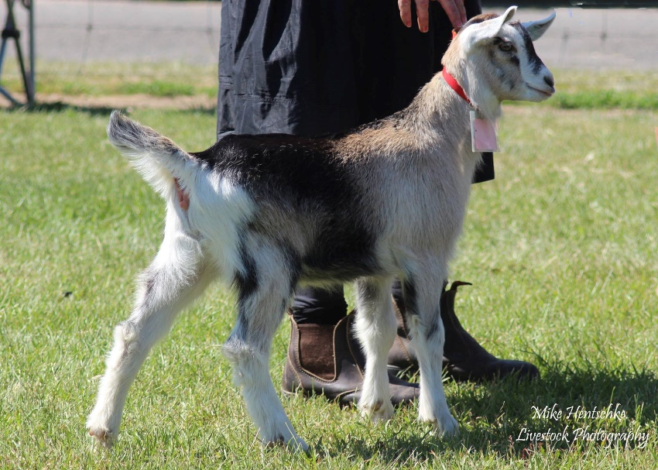
History
Alpine or French Alpine goats were first brought to North America in 1922. The breed had a good start there as the imports consisted of 19 does and 3 bucks. All modern goats registered as purebred Alpines in the United States are directly descended from these 22 animals.
Over time, crossbreeding of French Alpines with various breeds of goat produced the American Alpine, a sub-type of the Alpine dairy goat. This sub-type is generally a larger, stronger and a more productive, high yield animal than the pure French. The Alpine is now amongst the most numerous of the breeds in America.
Semen was imported into Australia in 2013 from two bucks of different studs, Iron-rod and Shining Moon. In May 2016 the Dairy Goat Society of Australia approved and provided a Standard and registration under the name of “Alpine”.
The first kids by artificial insemination were born in November 2014 and later accepted into the register. Breed semen having been available for just three years at writing (2016) finds the development of the breed in its infancy with as yet a small number of breeders beginning to assist in that development

Breed Standard
GENERAL APPEARANCE(style and quality): Tall, rangy and graceful, upstanding and alert with presence, having a smoothly blended body exhibiting pronounced triple dairy wedge shape, fine but not inclined to weakness. Does feminine, bucks obviously masculine in appearance.
HEAD (skull, eyes, mouth, nostrils): Head long with strong square muzzle, facial line dished or straight, polled or neatly disbudded. Eyes set well apart, full and bright. Ears erect and pointing slightly forward.
NECK:Blending smoothly into shoulders, with or without tassels. Does long and fine. Bucks fine and strong, not coarse.
BACKLINE:Back strong, straight and horizontal or rising slightly to the hips.
FOREQUARTERS:Withers fine and high, blending firmly into shoulders. Chest full between the forelegs, deep in bucks, fairly deep in does.
BODY(barrel): Abdomen well rounded, large, deep and wedge shaped. Of proportionate length and depth (to height).
HINDQUARTERS:Gradual slope from hips to tail, good width between hips and thurls. Rump long and flat, pin bones wide and prominent.
LEGS(hooves): Long, strong oval boned legs but not coarse or heavy. Front legs straight and parallel from front and side. Hindlegs straight and parallel viewed from rear, hocks slightly bent when seen from the side, pasterns fairly short and strong. Hooves sound and well-shaped.
UDDER:Back attachment high and broad, fore attachment carried well forward and blending smoothly to abdomen, not pendulous or unduly divided, showing good capacity. Skin colour tan to dark brown or grey to black, and softly textured.
TEATS(Two): Of adequate size for ease of milking, well attached and distinct from the udder. Set well apart, pointing slightly forward and down, not outward.
TESTICLES:Scrotum well attached, relatively even and not divided or unduly pendulous, carrying two testes.
RUDIMENTARY TEATS:Two set wide apart slightly to the fore and side of the scrotum, of good size but not overdeveloped, unless the buck is milking.
SIZE(height at withers): Does 83 centimetres (32 inches). Bucks 95 cm (37 inches).
COAT:Short, fine and glossy, may have a fine undercoat. Bucks may have a longer coat.
COLOUR:Any combination of colours or any pattern form (Toggenburg and solid white colour is a fault).
Supplementary Descriptions:To assist with identified varieties.
Main Identified Varieties:
Cou Blanc.White forequarters, black hindquarters, black / grey markings on head.
Cou Clair.Cream to tan or grey forequarters, black hindquarters.
Cou Noir.Black forequarters, white hindquarters.
Pied.Spotted or mottled.
Chamoisee.Cream to Brown with black face, dorsal stripe, legs & hooves; sometimes has a black “martingale” over the withers and down to the chest.
Two-tone Chamoisee.Light forequarters with brown or grey hindquarters.
Sundgau.Black body colour with white Swiss markings, may have white to grey under the belly. May also have white splash on side or forehead.
Broken.The term placed as a prefix to the colour type of any colour being banded, splashed, etc.
Skin Colour Including the Udder:
Cou Clair, Cou Blanc, Cou Noir, Pied:tan to black.
Chamoisee,tan or dark brown or black.
Sundgau,dark grey to black.
DIFFERING FROM IDEAL (found and recognised):Horned. Nose with slightly raised bridge. Uneven tassels, longer fringe along backline and hindquarters.
FAULTS:Cow hocks. Steeply sloping rump. Dropped pasterns. Roach back or sway back. Size differing substantially from ideal. Uneven gait. Poor feet. Splayed feet. Low set or pendulous ears. Weak or narrow chest. Shallow body. Lack of dairy quality. Fleshy, pendulous or unduly divided udder. Pocket in udder. Teats: small, thin, large, bulbous, ill-defined or unbalanced. Lack of milking capacity. Lack of masculinity in bucks. Divided, uneven or unduly pendulous scrotum. Toggenburg and solid white colour is undesirable.
DISQUALIFICATIONS:Obviously undershot or overshot jaw (side profile). Wry face. Udders which are white/pink skinned. Double teats, double orifices. Supernumerary teats. Intersex. Undescended testicles in bucks or one testicle only.

